Tracking cap opening and closing

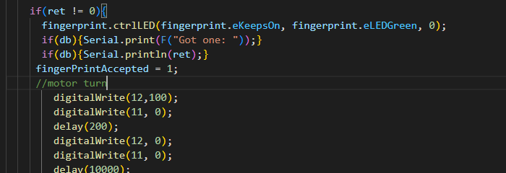

Biometric locking mechanism. opens if the finger has been detected and accepted

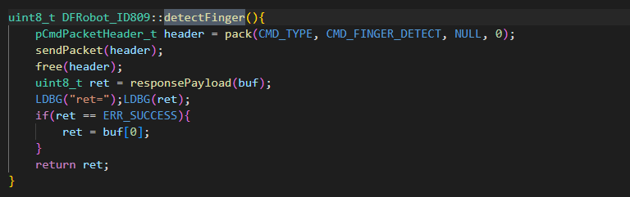

Content counter

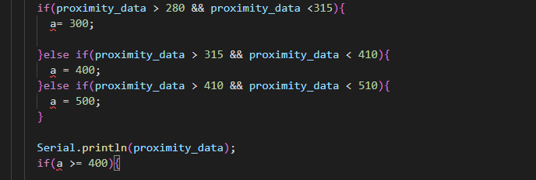

Pill bottle allocating signal

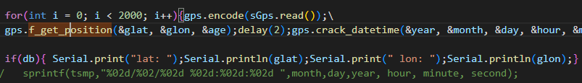

Synch to mobile app. connecting to TrackRx server.

